Basic Concepts in Remote Sensing
Lonkham Boruah
What is Remote Sensing:
The word remote sensing is comprised of two words: remote meaning away and sensing meaning observing or acquiring some information. Thus, remote sensing simply means acquiring information of something from distance. Remote Sensing is the science and art of obtaining information about the earth, whole or part, or any other object or phenomenon with the help of data acquired by a device(sensor), without any physical contact with it whether the sensor is immediately adjacent to the object or millions of kilometers away. Aircrafts and satellites are common platforms for remote sensing observation. Without direct contact, some means of transferring information through space must be utilized. A flow of energy, from the object being sensed to the sensing device, is necessary. The quantity most frequently measured in present day remote sensing systems is the electromagnetic energy emanating from the object of interest.
Here are a few definitions of remote sensing, which give an idea of what it means
D.P. Rao (NRSA) defines “Remote sensing is the science of deriving information about an object from measurements made at a distance from the object without actually coming in contact with it.”
Campbell defined “Remote sensing is the science of deriving information about the earth’s land and water areas from images acquired at a distance. It usually relies upon measurement of electromagnetic energy reflected or emitted from the features of interest.”
According to Canada Centre of Remote Sensing (CCRS), “Remote sensing is the science (and to some extent, art) of acquiring information about the earth’s surface without actually being in contact with it. This is done by sensing and recording reflected or emitted energy and processing, analyzing and applying that information.”
Basic Principles in Remote Sensing:
The whole remote sensing system is depends upon some basic principles as follows:
- In remote sensing, artificial sensors are used to collect earth surface information.
- These sensors are capable of detecting and recording EMR (Electromagnetic Radiation)
- The object under study must be an earth surface feature.
- The sensors of remote sensing work from a distance without contact with the objects under study.
- Platforms are used in remote sensing to keep the sensor away from the earth surface.
- In remote sensing, we make use of electromagnetic energy. The energy emitted or reflected by the objects or geographical area is recorded by an artificial sensor from a distant vintage point.
- Basic principle on which the whole remote sensing is works is that any object having temperature more than -273˚C emits energy. This temperature is called absolute temperature or absolute zero.
Basis of remote sensing technique: The whole underlying principle on which the whole remote sensing technique is developed, is that all objects on the surface of the earth have characteristic Spectral Signatures. A spectral signature of an object or a ground surface feature is a set of values for the reflectance or radiance of the feature, each value corresponding to the reflectance or radiance arranged over a different, well defined wavelength interval. The knowledge of spectral signature is very essential for exploiting the potential of remote sensing techniques. It enables one to identify and classify the objects. It is also required for interpretation of all remotely sensed data whether the interpretation is carried out visually or using digital techniques. It also helps us in specifying requirements for any remote sensing mission e.g. which optimal wavelength band to be used or which type of sensor will be best suited for a particular task. This is also necessary for analyzing and designing sensor system for specific applications.

Components of Remote Sensing:

Remote Sensing Process:
Remote Sensing involves a number of processes as follows to acquire the end information
- Transmission of electromagnetic energy from the source (sun) to the surface of the earth and its interaction with the intervening atmosphere.
- Interaction of energy with the earth surface (reflection/absorption/transmission) or self-emission.
- Transmission of reflected/emitted energy to the remote sensor placed on suitable platform
- Detection of energy by the sensor converting it into photographic image or electrical output.
- Transmission/recording of the sensor output.
- Pre-processing of the data to generate data products.
- Collection of Ground Truth and other collateral information.
- Data processing and interpretation.
- Application of the data.

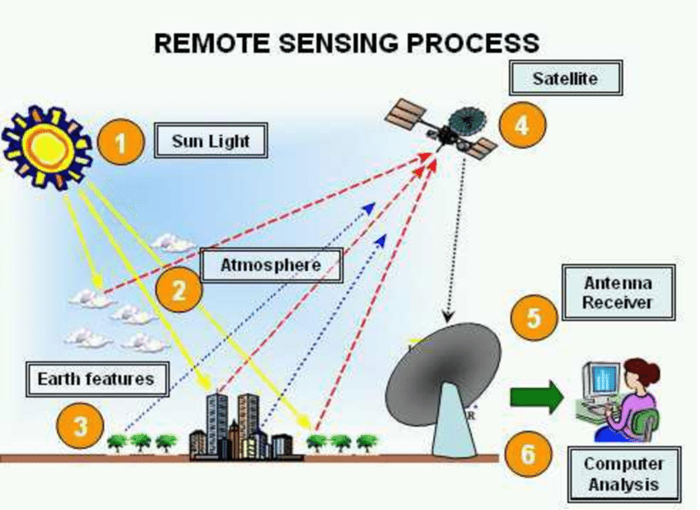

Advantages of Remote Sensing:
- It collects data systematically and removes sampling bias.
- A remote sensing sensor has synoptic view. It has the ability to see large areas at the same time; thus, it consumes less time or reduces time to acquire information about a larger area. For example: to prepare a land-use map of Pathsala through traditional cartographic method may take a month or more time but, with the aid of remote sensing techniques with can be prepared with a short span of time.
- It provides continuous monitoring of earth surface features at regular time interval.
- It can collect data of politically (like some politically unstable places of Jammu and Kashmir) and physically (hilly and dense forested areas bordering India and Myanmar) inaccessible areas.
- It provides fundamental biophysical data such as location, depth or elevation, temperature, moisture content etc. which can be used for other scientific investigations.
- It helps us to acquire much more information about an area and which can be secured compared to that obtained with conventional photography which is limited to the visible band of the spectrum as it works in other bands of the spectrum which are invisible to human eyes.
Disadvantages or Limitations of Remote Sensing:
- Remote sensing data product are very expensive to collect, and to analyze (costly image, and software cost more than lakhs of rupees).
- They are not direct samples of the phenomenon, so may be calibrated against reality.
- They must be corrected geometrically and georeferenced in order to make them useful for production of maps or for other applications.
- In many cases, distinct phenomena can be confused, if they look same to the sensor, leading to error; e.g. - difference between natural and artificial grass in green light.
- Resolution of satellite imagery is too coarse for detailed mapping and for distinguishing small contrasting areas.
- Technical know-how and some prior knowledge are required for analysis and interpretation of remote sensing data products.
Application and Scope of Remote Sensing:
The information acquired from remotely sensed photographs and images are useful to investigators in many diverse disciplines.
- Military purposes: The oldest application of remote sensing technique is in military operation. Infra-red sensing is very useful in military operation as infra-red images can be passively made at night. As radar and infra-red sensing does not require sending out energy to be reflected and perhaps detected by an enemy. Infra-red sensing is particularly useful in providing data that can be used to locate an enemy’s position, to estimate his numbers and to detect his movements. Movement or activity whether of bodies or vehicles, generates extra heat, thus, an infra-red scanner carried by an air plane can gather a surprisingly large amount of information on enemy maneuvers. And it is also useful in missile guidance. Recently a few countries designed anti-missile satellite to incapacitates or destroy satellites for strategic military purposes.
- Infra-red sensing is also very useful in detecting and mapping of forest fires.
- Geologists use remote sensing to find deposits of minerals and petroleum.
- Soil scientists can prepare inventory of the important characteristics of soil by relating them to geological and geomorphological features and the type of vegetation found on images obtained by remote sensing.
- Foresters and Agriculturalists can determine the kind of trees and plants which grow in an area, can assess their health and estimate their yield.
- Hydrologists used remote sensing techniques to locate useful aquifers and can estimate the volume of surface and sub-surface watershed.
- Oceanographers can map the movements of ocean currents, marine organisms and water pollutants.
- Geographers can analyze land-use patterns over large area and can study the effect of climate, topography, plant life, animal life and human activity in a particular area.
- Civil Engineers planning large co0nstruction projects such as highways, airports, railways or dams can obtain data on landforms, rock materials, soils, type of vegetation and drainage condition in the project area.
- Remote sensing is invaluable to Map Makers in their efforts to identify ground features and to position them accurately.
- Wild Life Manager can use aerial photographs for locating habitats of various kinds of animals. And also can detect illegal activities going on in the forests.
- Violations of natural laws often show up in photographs e.g. illegal mining in remote areas, pollution of water by illegal dumping of chemicals and effluents from industries, air pollution due to release of smoke and poisonous gases through chimneys of industries.
- The analysis of Disasters like floods, fires and cyclones can be assisted by the study of remote sensing data and the information so obtained can be used in making emergency decisions and in combating the situation.
- Fast development in industrialization throughout the world is causing the serious problem of environmental pollution; monitoring of this can be effectively tackled by employing remote sensing techniques.
- Remote sensing technology provides timely and reliable information for effective management of diminishing sources of natural resources and monitoring the quality of our environment in comparison to the conventional methods.

